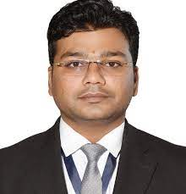

Faculty Profile

Mr. Rahul Vilas Jodh

|  |  |  |
| --- | --- | --- |
| **Qualifications** | **: M. Pharm** | |
| **Specialization** | **: Pharmacology** | |
| **Department** | **: Pharmacy** | |
| **Designation** | **: Principal** | |
| **Experience** | **Industry: 6 Y** | **Teaching: 6 Y** |
| **Publication** | **: 30** | |
| **Award/Recognition** | **: -** | |
| **Membership** | **: APTI, MSPC** | |
| **Email** | **: jodhrahul@gmail.com** | |